**Student Driver policy statement**

**Introduction:**

Hull University Union encourages and supports students to take part in a range of activities through sports and societies in particular. This can often mean travel to and from sporting activities or society events. The Union recommends that trips are undertaken where possible in regulated vehicles such as hire coaches (with driver) and officially licensed self-drive vehicles The Union can arrange hire and insurance cover for both 9 seater vehicles and minibuses. The Union also acknowledges that sometimes students prefer to use their own vehicle for such trips including to transport other students as well as themselves to the activities or events. This policy outlines the requirements of Volunteer drivers (Volunteer drivers are defined as drivers who transport team mates or participants to and from activities and claim expenses including fuel from Hull University Union for doing so.)

This policy accepts that on occasions Hull University Social Services Organisation (HUSSO) participants may use their own vehicles to travel to and from their volunteer placement, however they must not use their own vehicle to transport anyone other than themselves in connection with their volunteering activity.

**Vehicle hire:**

The club or society needing transport must contact the SVOT team at the Union to request transport hire, and to complete all relevant paperwork seven days/weeks prior to any event. A trip pack must be received at least seven days in advance of the event. Trip packs can be found on the website and at the One Stop Area and must be posted in the box provided for authorisation.

**Insurance for hire vehicle drivers:**

Hull University Union’s insurance company can insure drivers for all hire vehicles. In order to fulfil our obligations to our insurance company **ALL** drivers of hire vehicles must complete our standard driver declaration form, and from this contact the SVOT team if they are subject to any of the non-standard driver conditions (see appendix 3 and 5). If a student meets one or more of the non-standard driver criteria set out on the form they must complete a non-standard driver declaration from which is then sent to the Union’s insurer for approval. (See flowchart in appendix.1) providing our insurer approves the non-standard driver, and for all standard drivers these forms are only completed once (at the first hire arrangement) all documentation required and the forms will be stored within the individuals data record (SUMS) in accordance with our GDPR policies. The process requires all registered drivers to contact the Union in the event of any change of circumstance in their driving status. The process also requires all drivers to comply with our Responsibilities of a standard driver document (see Appendix 2).

**Use of own vehicle:**

Students who transport other students for the purpose of trips in their own vehicles, can do so on behalf of their club or society if they complete the private vehicle declaration form (see appendix 4). If they wish to claim fuel allowance for the

journeys taken they must provide the relevant insurance evidence, and receipts/evidence of the mileage travelled.

The Union does not check or inspect private vehicles and does not accept any responsibility or liability for checking or inspecting private vehicles used for trips off-campus. Where private vehicles are used for such trips, it is the responsibility of drivers and their passengers to comply with all relevant legislation and safety standards and in particular all requirements in respect of third party insurance under the Road Traffic Act 1988,

All documentation required as part of the private vehicle declaration form will be stored within the individuals data record (SUMS) in accordance with our GDPR policies. The process requires all registered drivers to contact the Union in the event of any change of circumstance; this could include a failed MOT, refused insurance or a change to the student’s driver status).

**Insurance for use of Private vehicles:**

In order for a student to make a fuel claim for a trip including passengers, the Union require evidence that their own insurer is informed of their activity and that they are insured for such trips. All students wishing to make fuel claims must have either “Business use” on their insurance or some insurer’s cover what is referred to as “volunteer driving” within regular motor insurance policies. In both cases Business Use and Volunteer driving some insurers may charge an extra premium or impose a higher excess for volunteer drivers. **Students must contact their insurer before carrying out any trips.**

A number of insurance providers are signed up to the Association of British Insurers (“ABI”) “Volunteer Driving Motor Insurance Commitment” (see appendix , meaning they will cover volunteer drivers who use their own vehicle for specified purposes without any extra charge and the driver can claim back mileage for volunteer journeys (provided it does not exceed the HMRC mileage rates in force at that time (see table below). The Volunteer drivers motor insurers listed (see appendix 4) will insure their policyholders to carry out voluntary driving, which they define as, the use of a vehicle the policyholder owns in connection with, or for the benefit of, charities, voluntary organisations, clubs or societies.

The insurers listed in the commitment allow payment of mileage to be made to volunteer drivers for the journeys undertaken for the purposes listed where the driver has complied with the conditions set out in the table and payment of mileage does not exceed the HMRC mileage rates in force at that time.

The mileage rates set out on the HMRC website are as follows;

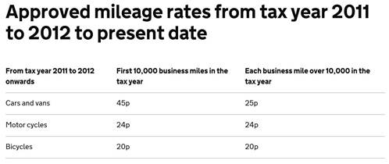

These rates are occasionally subject to change and will be checked regularly.

**In all circumstances, if someone uses their own vehicle for volunteer driving, they must:**

* Contact their insurer to notify them of their intention to undertake volunteer journeys and discuss any implications.
* Include their volunteer driving miles when declaring their annual mileage to their insurer.
* Provide evidence of their insurance policy and their contact with their insurer to Hull University Union.

Appendices

1. Flow diagram
2. Responsibilities of a standard driver
3. Standard driver declaration form
4. Private Vehicle declaration form
5. Non-standard driver declaration form
6. ABI Insurers list
7. Log sheets for standard and non-standard drivers

**Appendix one**

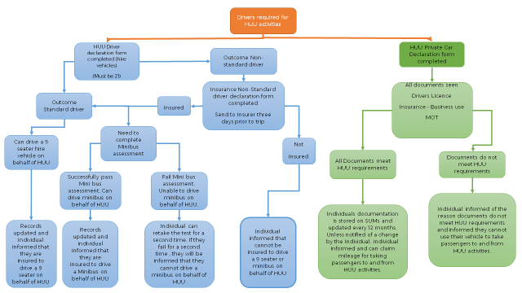

**Appendix two**

**Responsibilities of a Standard Driver**

* It is your responsibility to notify us of any changes to your driver licence (i.e. points, convictions, etc), driving entitlements, medical updates that affect driving or contact details (i.e. email, phone, address).

* You need to ensure that the vehicle hired is brought back with a full tank of fuel, unless otherwise stated by the hire company, so check if it is petrol or diesel, to avoid any unnecessary vehicle repairs.
* Familiarise yourself with the vehicle, adjusting your seat and mirrors, and identify the required controls. The hire company will do a walk around of the vehicle and will have left a check sheet on the dashboard. Check the lights and brakes, before you set off on your journey.
* It is important that you are prepared physically and mentally before setting off on a journey. If you feel tired, stressed, ill or distracted we advise you not to drive. Ensure you have plenty of rest before a journey and if you feel unwell notify the committee. With each vehicle you should have two registered drivers so the driving can be shared, especially on long journeys.

* When driving, you need to ensure you do not drive for longer than 5 hours 30 minutes after which you must take a break of at least 30 minutes for rest and refreshment and you must not drive no longer than 10 hours in a day. Avoid driving late at night/early hours, where possible, and do not drink the night before driving as this increases your chances of being over the drink drive limit or tired.

* As a driver you must adhere to all road safety laws to ensure the safety and comfort of the passengers on board your vehicle, whether in a hire or personal vehicle. You have a responsibility to yourself, passengers and other road users. You must ensure all passengers are wearing their seat belt and remain in their seats for the entire journey.

* Do not use a mobile phone whilst driving. Switch off your phone or ask another passenger to deal with any calls if they are urgent. Avoid drinking and eating whilst driving and smoking is prohibited in any hire vehicle.



**Appendix three**

**Standard Driver Declaration Form for Hired Vehicles**

Hull University Union recommends that trips are undertaken in regulated vehicles such as coaches and officially licensed minibuses.

Where hire vehicles are to be used for trips, drivers must complete the following details, **provide all required documentation stated on page two and sign the declaration below.**

Club/Society: ..............................................................................................

Driver’s name: …………...................................................................................................

Driver’s address: …………….............................................................................................

Postcode: .............................................................................................................................

Contact number: ................................................................................................................

If **any** of the below points apply to you please request a Non-Standard Driving Form by emailing v.dean@hull.ac.uk

* A Driver with a non-UK/EU Licence other than Norway, Channel Islands and Isle of Man
* Drivers over the age of 70
* Drivers who have disclosed a medical condition reportable to DVLA
* Drivers who have disclosed any accidents in the past 3 years
* Drivers who have disclosed any motoring convictions

**I confirm that none of the above statements applies to myself** 

**As the above named driver, I confirm and declare that:**

* I will not use a handheld mobile phone whilst driving. Use of a handheld mobile phone will only occur once the car is at a stop, the engine turn off and keys removed.
* After 5 hours 30 minutes of driving, you must take a break of at least 30 minutes for rest and refreshment.
* If required I have taken advice on safe driving practices and formal training (i.e. for minibuses) **tick here**
* No-one other than me (and ..................................................................) will drive the Vehicle during the Trip;*
* I understand that I have sole responsibility for the safety of my passengers and other road users while I am driving.
* I understand that if any of these circumstances change of the documentation provided I will inform HUU

Signed……………………………………………………….

Print Name………………………………………………………….

Date………………………………………………………….

**OFFICE USE ONLY**

I confirm that I have received and approve of the following documentation.

1. A current, valid driving licence which authorises the student to drive the above named vehicle;

Signed: ...............................................................................................................................................

Print name: .......................................................................Date:................................................................

*If another driver is to drive the Vehicle, s/he must also complete a declaration.



**Appendix four**

**Private Vehicle Declaration**

Hull University Union recommends that trips are undertaken in regulated vehicles such as coaches and officially licensed minibuses. (HUSSO participants may not travel in private cars).

The Union does not check or inspect private vehicles and does not accept any responsibility or liability for checking or inspecting private vehicles used for trips off-campus. Where private vehicles are used for such trips, it is the responsibility of drivers and their passengers to comply with all relevant legislation and safety standards and in particular all requirements in respect of third party insurance under the Road Traffic Act 1988,

Drivers of private vehicles must accept sole responsibility for the safety of passengers and other road users and must sign a declaration confirming this.

Where private vehicles are to be used for trip, drivers must complete the following details, **provide all required documentation stated on page two and sign the declaration below.**

Club/Society:..............................................................................................

Driver’s name: …………...................................................................................................

Driver’s address: ……………..........................................................................................Postcode.............................................................................................

Contact number: ................................................................................................................

Vehicle Make and Model ...........................................................Registration number: ………………………………………………………

As the above named driver, I confirm and declare that:

* The vehicle I intend to drive is technically safe and roadworthy to carry passengers
* I will not use a handheld mobile phone whilst driving. Use of a handheld mobile phone will only occur once the car is at a stop, the engine turn off and keys removed.
* After 5 hours 30 minutes of driving you must take a break of at least 30 minutes for rest and refreshment.
* If required I have taken advice on safe driving practices and formal training (i.e. for minibuses) **tick here**
* No-one other than me (and ..................................................................) will drive the Vehicle during the Trip;*
* I understand that I have sole responsibility for the safety of my passengers and other road users while I am driving.
* I understand that if any of these circumstances change of the documentation provided I will inform HUU

Signed……………………………………………………….

Print Name………………………………………………………….

Date………………………………………………………….

**OFFICE USE ONLY**

I confirm that I have received and approve of the following documentation.

1. A current, valid driving licence which authorises the student to drive the above named vehicle;
2. A valid insurance which includes **business use** in respect of third party risks in relation to the Vehicle and the Trip which complies with the requirement of s.143 and Part VI of the Road Traffic Act 1988;
3. Where appropriate, a current MOT certificate for the Vehicle;

Signed: ...............................................................................................................................................

Print name: .......................................................................Date:................................................................

*If another driver is to drive the Vehicle, s/he must also complete a declaration.

**Appendix five**

|  |
| --- |
| **Non-Standard Driver Declaration Form** |

|  |  |  |  |  |  |  |  |  |  |  |  |  |  |  |  |  |  |  |  |  |  |  |  |  |  |  |  |  |  |  |  |  |  |  |  |  |  |  |  |  |  |  |  |  |  |  |
| --- | --- | --- | --- | --- | --- | --- | --- | --- | --- | --- | --- | --- | --- | --- | --- | --- | --- | --- | --- | --- | --- | --- | --- | --- | --- | --- | --- | --- | --- | --- | --- | --- | --- | --- | --- | --- | --- | --- | --- | --- | --- | --- | --- | --- | --- | --- |
| Full Name of Union / Policyholder | | | | | | | | | | | | | | |  | | | Policy Number | | | | | | | | | | | | | | | | | | | | | | | | | | | | |
|  | | | | | | | | | | | | | | |  | | |  | | | | | | | | | | | | | | | | | | | | | | | | | | | | |
|  |  |  |  |  |  | | |  | |  | |  | |  | |  | | |  | |  | |  | |  | | |  | | |  | | |  | | | | |  | | |  | | |  | | |
| E-mail Address for Reply (should be a Union address, not driver’s own email address) | | | | | | | | | | | | | | | | | | | | | | | | | | | | | | | | |  | | | | |  | | |  | | |  | | |
|  | | | | | | | | | | | | | | | | | | | | | | | | | | | | | | | | | | | | | | | | | | | | | | |
|  |  |  |  |  |  | | |  | |  | |  | |  | |  | | |  | |  | |  | |  | |  | | | |  | | |  | | | | |  | | |  | | |  | | |
| Full Name of Driver | | | | | | | | | | | | | | |  | | | Date of Birth | | | | | | | |  | | | | Type of Licence (circle) | | | | | | | | | | | | | | | | |
|  | | | | | | | | | | | | | | |  | | | / / | | | | | | | |  | | | | UK / EU / Non-EU | | | | | | | | | | | | | | | | |
|  |  |  |  |  |  | |  | |  | |  | |  | |  | | |  | |  | |  | |  | |  | | | |  | | |  | | | | |  | | |  | | |  | | |
| Date Driving Test Passed | | | |  | Country of Licence Issue | | | | | | | | | | | | | | | | | |  | | | How long since test passed | | | | | | | | | | | | | | | | | | | | |
|  | | | |  |  | | | | | | | | | | | | | | | | | |  | | |  | | | | | | | | | | | | | | | | | | | | |
|  |  |  |  |  |  | |  | |  | |  | |  | |  | | |  | |  | |  | |  | |  | | | |  | | |  | | | | |  | | |  | | |  | | |
| **Please answer all of the following questions by circling the appropriate answer and providing full details where applicable:** | | | | | | | | | | | | | | | | | | | | | | | | | | | | | | | | | | | | | | | | | | | | | | |
|  |  |  |  |  |  | | |  | |  | |  | |  | |  | | |  | |  | |  | |  | | |  | | |  | | |  | | | |  | | | |  | | |  | | |
| 1. Do you have any medical conditions requiring notification to the DVLA or which may affect driving? | | | | | | | | | | | | | | | | | | | | | | | | | | | | | | | | |  | | | | YES / NO | | | | | | | | | |
|  |  |  |  |  |  | | |  | |  | |  | |  | |  | | |  | |  | |  | |  | | |  | | |  | | |  | | | |  | | | |  | | |  | | |
| If “YES” please give details of condition(s), medication and any special terms imposed: | | | |  |  | | | | | | | | | | | | | | | | | | | | | | | | | | | | | | | | | | | | | | | | | | |
|  |  | | | | | | | | | | | | | | | | | | | | | | | | | | | | | | | | | | | | | | | | | | |
|  |  | | |  | |  | |  | |  | |  | | |  | |  | |  | |  | | |  | | |  | | |  | | | | |  | | |  | | |  | | |
|  | | | | | | | | | | | | | | | | | | | | | | | | | | | | | | | | | | | | | | | | | | | | | | |
| 2. Have you had any motor accidents or made any claims (including theft) in the last **3** years? | | | | | | | | | | | | | | | | | | | | | | | | | | | | | | | | |  | | | | | YES / NO | | | | | | | | |
|  |  | | | | | | | | | | | | | | | | | | | | | | | | | | | | | | | | | | | | | | | | | | | | | |
| If “YES” please give full details here: | | | |  | Incident Date: | | | | | | | Circumstances:  (Brief description of what happened). | | | | | | | | | | | | | | | | | Total cost:  (Own & Third Party costs, & whether claim made or not): | | | | | | | | | | | | | No Claims Discount affected? | | | | | |
|  | | | | | / / | | | | | | |  | | | | | | | | | | | | | | | | | £ | | | | | | | | | | | | |  | | | | | |
| / / | | | | | | |  | | | | | | | | | | | | | | | | | £ | | | | | | | | | | | | |  | | | | | |
| / / | | | | | | |  | | | | | | | | | | | | | | | | | £ | | | | | | | | | | | | |  | | | | | |
| / / | | | | | | |  | | | | | | | | | | | | | | | | | £ | | | | | | | | | | | | |  | | | | | |
|  |  |  |  |  |  | | |  | |  | |  | |  | |  | | |  | |  | |  | |  | | | |  | | |  | | | |  | | | |  | | |  | | |  | | |
| 3. Have you had (or have pending) any convictions in connection with a motor vehicle in the last **5** years? | | | | | | | | | | | | | | | | | | | | | | | | | | | | | | | | |  | | | | | YES / NO | | | | | | | | |
|  |  |  |  |  |  | | |  | |  | |  | |  | |  |  | | | |  | |  | |  | | |  |  | | | | |  | | | | |  | | |  | | |  | | |
| If “YES” please give details here | | | |  | Date of Conviction | | | | | | | Conviction (Offence) Code | | | | | Circumstances | | | | | | | | | | | | Disqualification Period (Length) | | | | | | | | | | | | | Fine (£) | | | | | |
|  | | | | | / / | | | | | | |  | | | | |  | | | | | | | | | | | |  | | | | | | | | | | | | | £ | | | | | |
| / / | | | | | | |  | | | | |  | | | | | | | | | | | |  | | | | | | | | | | | | | £ | | | | | |
| / / | | | | | | |  | | | | |  | | | | | | | | | | | |  | | | | | | | | | | | | | £ | | | | | |
| / / | | | | | | |  | | | | |  | | | | | | | | | | | |  | | | | | | | | | | | | | £ | | | | | |
|  | | | | | | | | | | | | | | | | | | | | | | | | | | | | | | | | | | | | | | | | | | | | | | |
| 4. Has any insurance company or underwriter refused you any insurance or imposed any special terms? | | | | | | | | | | | | | | | | | | | | | | | | | | | | | | | | |  | | | | | YES / NO | | | | | | | | |
|  |  |  |  |  |  | | |  | |  | |  | |  | |  | | |  | |  | |  | |  | | |  | | |  | | |  | | | | |  | | |  | | |  | | |
| If “YES” please give full details including reason, date and any terms applied here: | | | | |  | | | | | | | | | | | | | | | | | | | | | | | | | | | | | | | | | | | | | | | | | | |
|  | | | | | | | | | | | | | | | | | | | | | | | | | | | | | | | | | | | | | | | | | | |
|  | | | | | | | | | | | | | | | | | | | | | | | | | | | | | | | | | | | | | | | | | | |
| I declare that the above particulars are true and correct to the best of my knowledge and that no material information which could affect the insurer’s assessment or acceptance of this risk has been withheld. | | | | | | | | | | | | | | | | | | | | | | | | | | | | | | | | | | | | | | | | | | | | | | |
|  |  |  |  |  |  |  | | | |  | |  | |  | |  | | |  | |  | |  | |  | | |  | | |  | | |  |  | | | | | | |  | | |  | | |
| Driver’s Signature: | | | | |  | | | | | | | | | | | | | | | | | |  | | Date: | | | | | | | | |  | / / | | | | | | | | | | | | |
|  |

|  |
| --- |
| **Non-Standard Additional Drivers Declaration**  **Driver Guidance Notes:** |

**If you are a Non-Standard driver:**

* Please complete all sections of the form. Forms submitted with blank fields, which state “Unknown” or similar for a required question, or forms which are not signed and dated by the driver will be rejected.
* Drivers under the age of 21 years may only drive vehicles with 8 or fewer passenger seats.
* All drivers must have held their full licence for at least 12 months.
* If you have any queries relating to this form, please contact us on 0333 234 1388 or [student.drivers@endsleigh.co.uk](mailto:student.drivers@endsleigh.co.uk)

**Question 1:** If answered “YES”, please give details of all medication taken, confirm whether the DVLA have been made aware of your condition and detail any driving restrictions imposed.

(Defective vision corrected by glasses or contact lenses does not need to be declared).

**Question 2:** Please explain the actual circumstances of the accident or claim (what happened).

Please include details of all incidents involving vehicles owned and/or driven by you.

Please confirm the total costs arising from the accident, irrespective of whether you made a claim and include any own repairs, third party repairs, compensation and costs etc. “Unknown” or similar cannot be accepted and we will be unable to approve you.

**Question 3:** Please ensure that you quote the correct conviction (Offence) code (e.g. SP30).

The date must be the date of the conviction, not the date of the offence.

If you have a drink-driving conviction, please give the blood/alcohol level at the time of the offence.

Offences must be declared where the date of conviction is within the last **five** **years,** regardless of whether or not the conviction is still shown on the licence.

**Question 4:** Please give full reasons for any refusal of insurance or any special terms applied by insurers. Please also include the date(s) of when this occurred.

**Additional Info:** Please ensure you provide a full clear and legible copy of your driving licence (front and rear of photo card).

Please ensure you have signed and dated the form before passing to the Union.

Please note you must not drive until approval has been granted by the Union.

**It remains the responsibility of the Union to ensure that all drivers driving under your policy hold a suitable valid licence to drive the class of vehicle in question.**

**Data Protection**

Endsleigh is committed to being transparent about how we handle your data and protect your privacy.

Full details can be found within our privacy policy. Please visit [endsleigh.co.uk/privacy](http://www.endsleigh.co.uk/privacy) for details.

Endsleigh Insurance Services Limited (Company no: 856706) is authorised and regulated by the Financial Conduct Authority. This can be checked on the Financial Services Register by visiting their website at www.fca.org.uk/register. Endsleigh Insurance Services Limited is registered in England at Shurdington Road, Cheltenham Spa, Gloucestershire GL51 4UE.

**Appendix six**

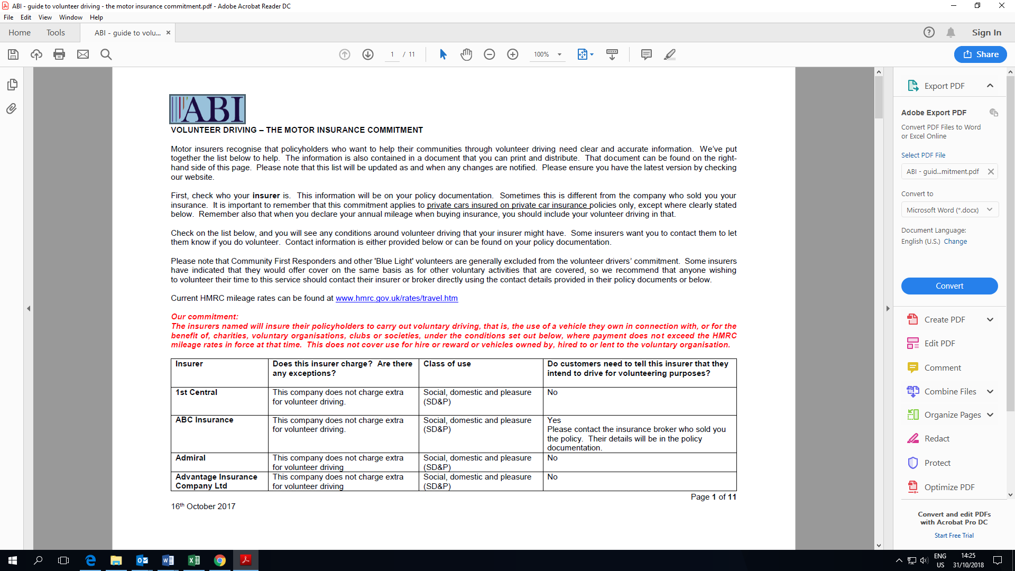

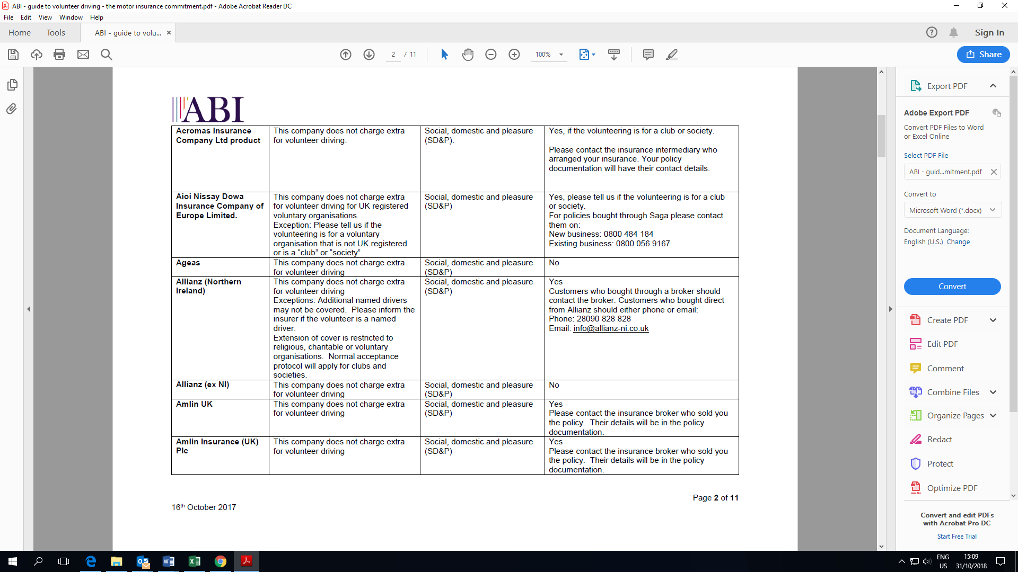

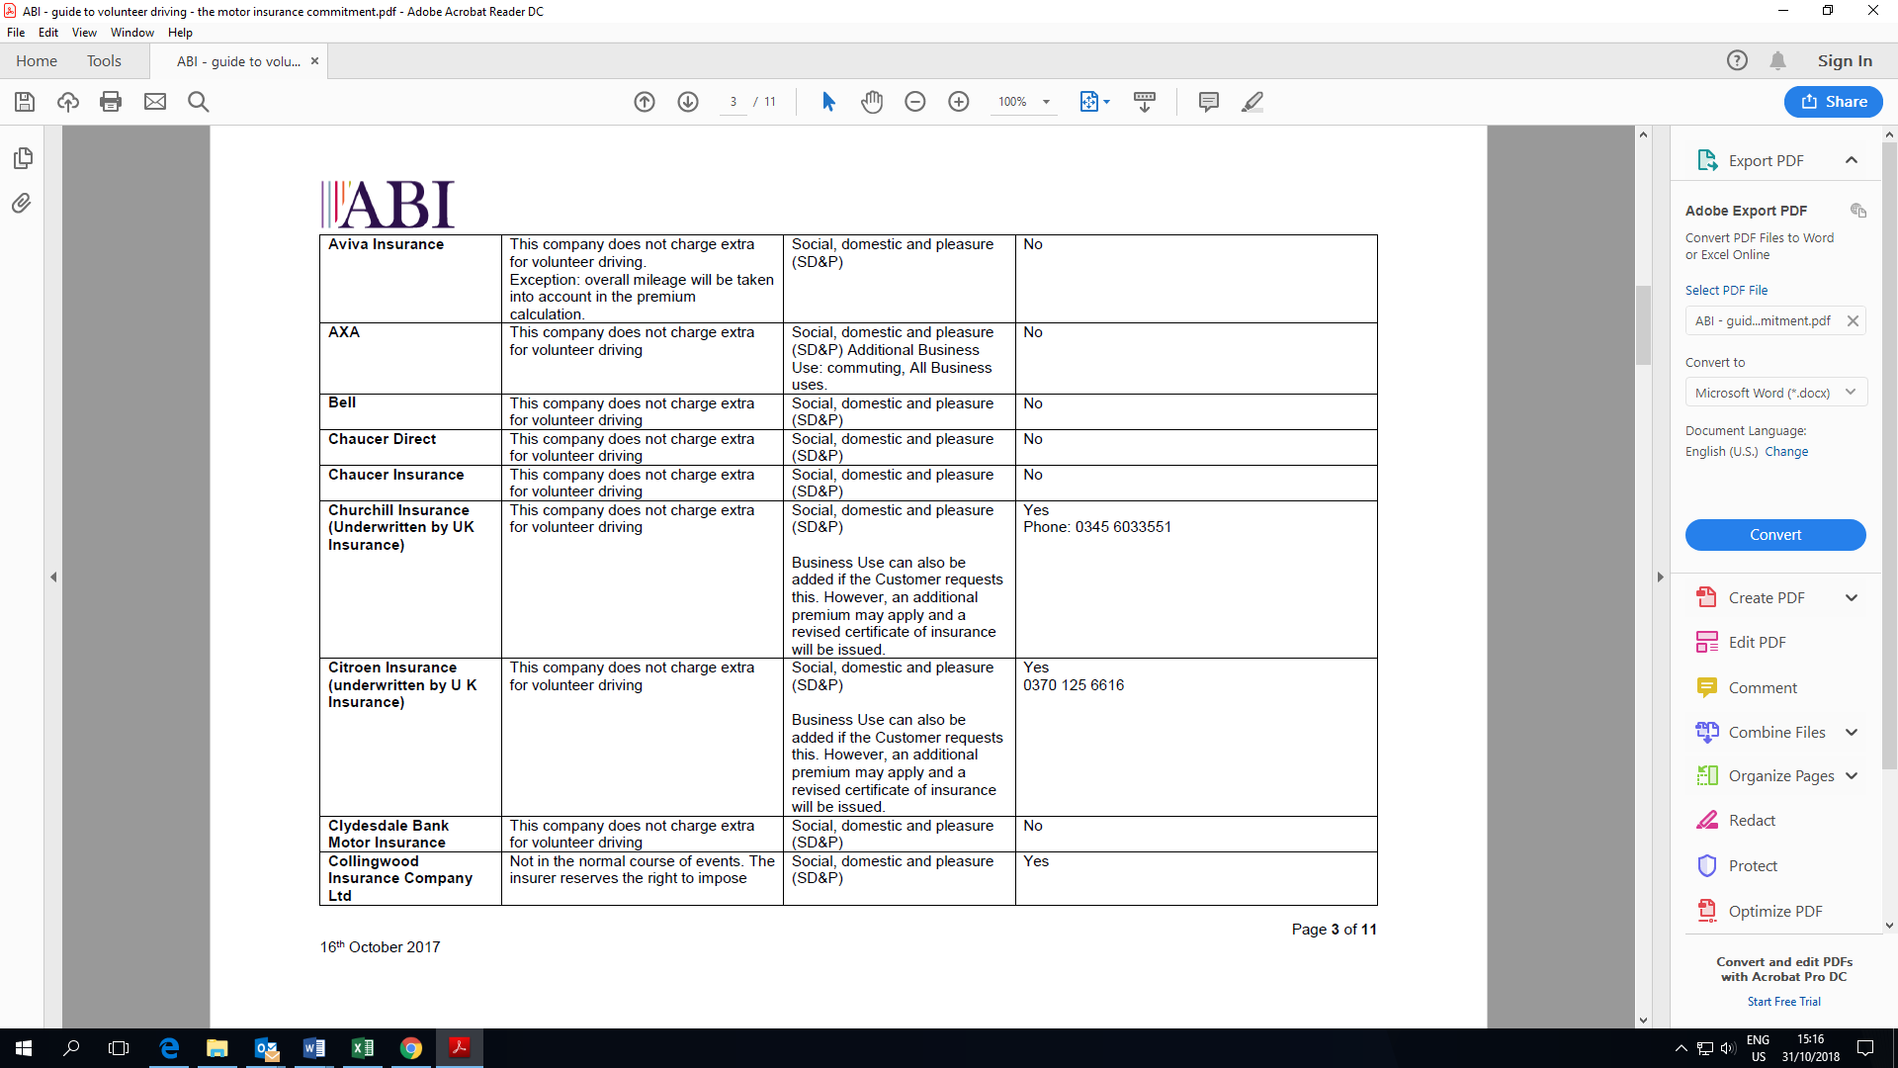

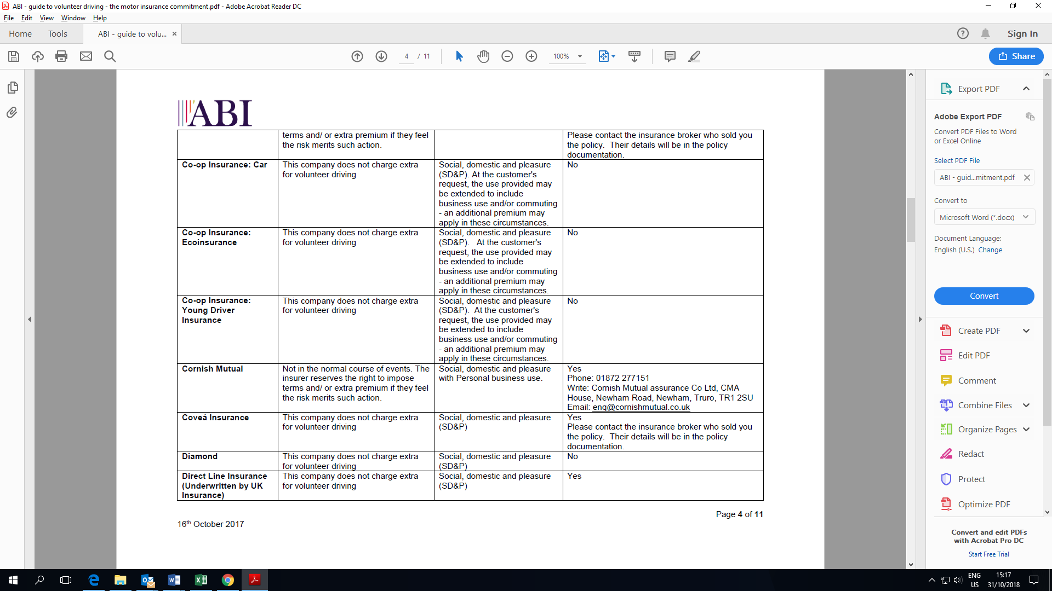

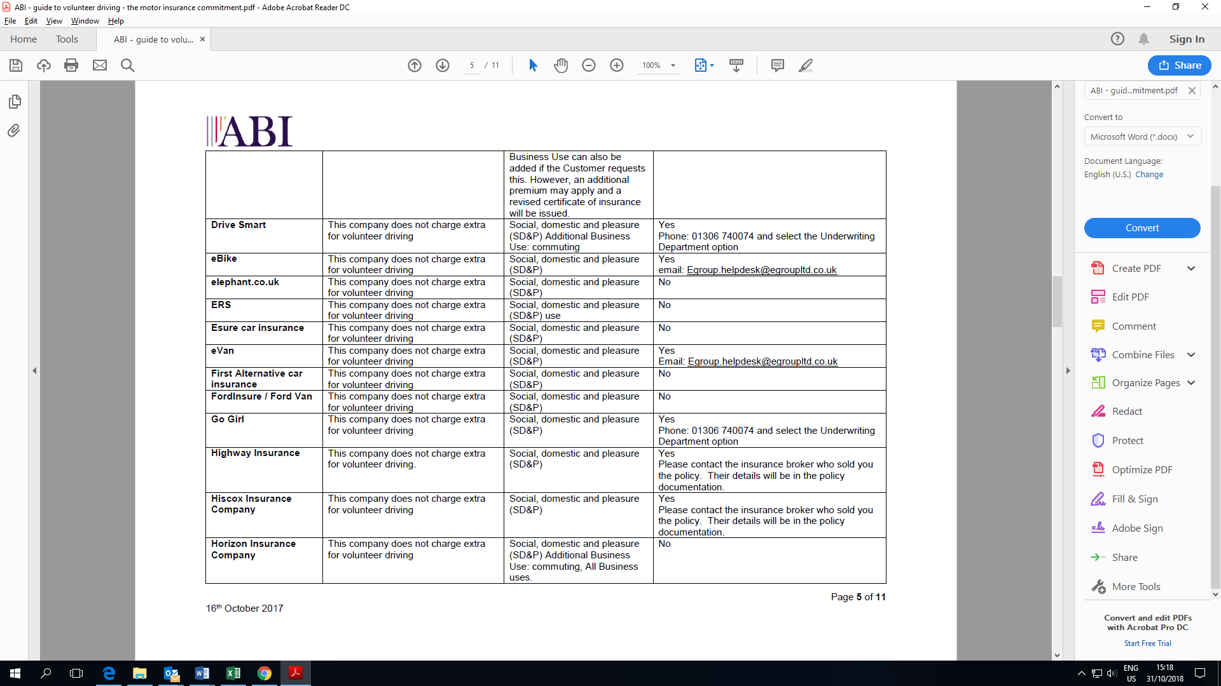

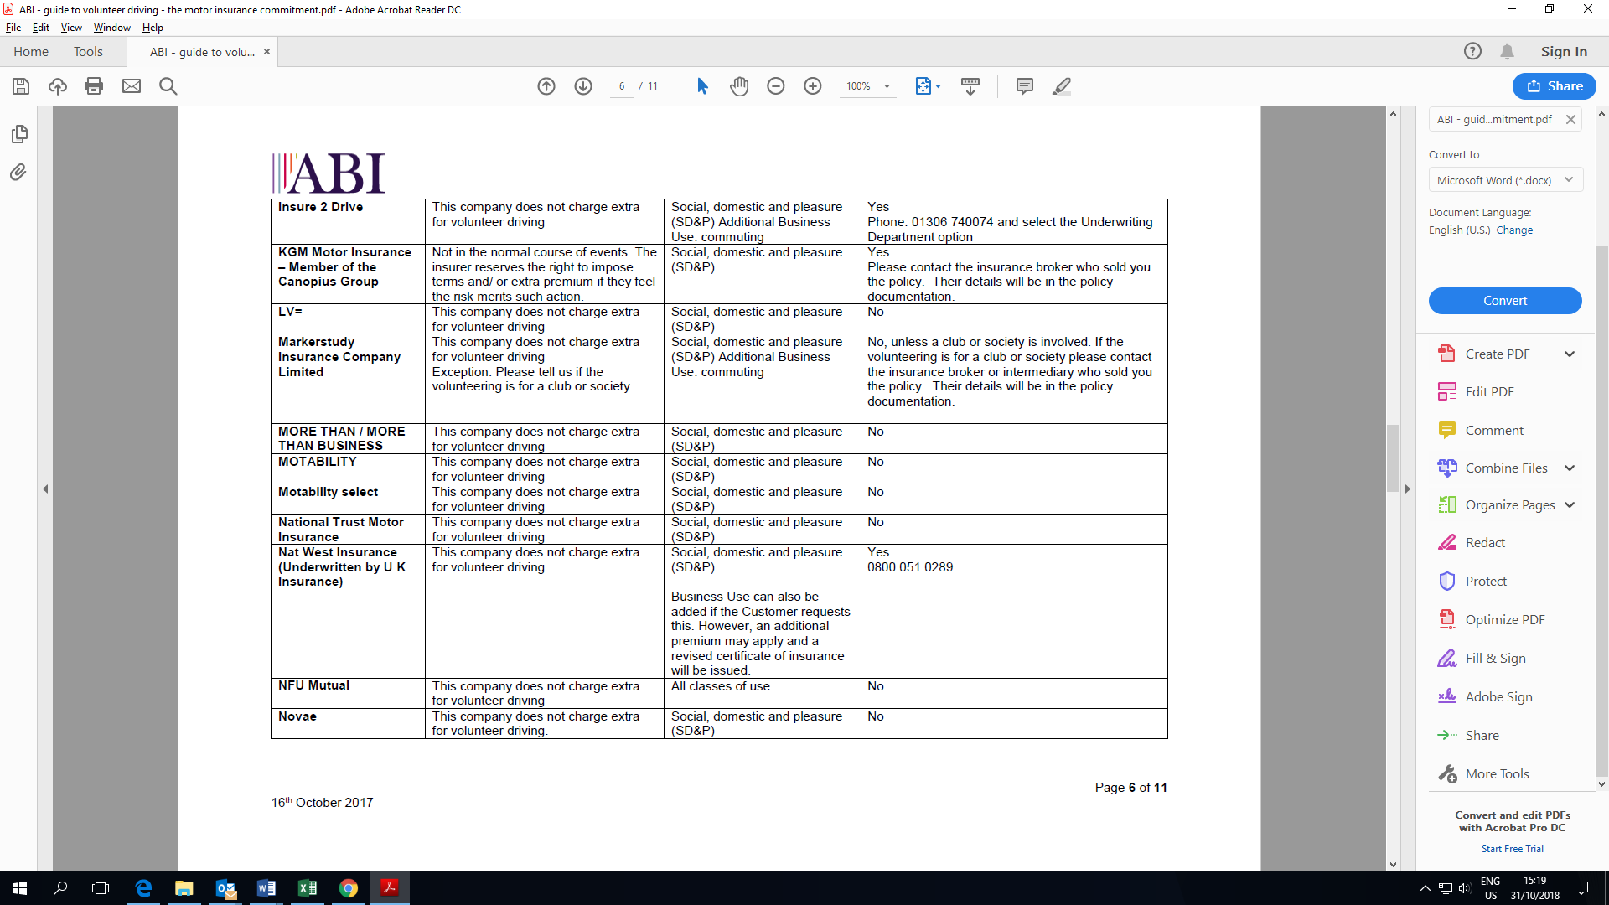

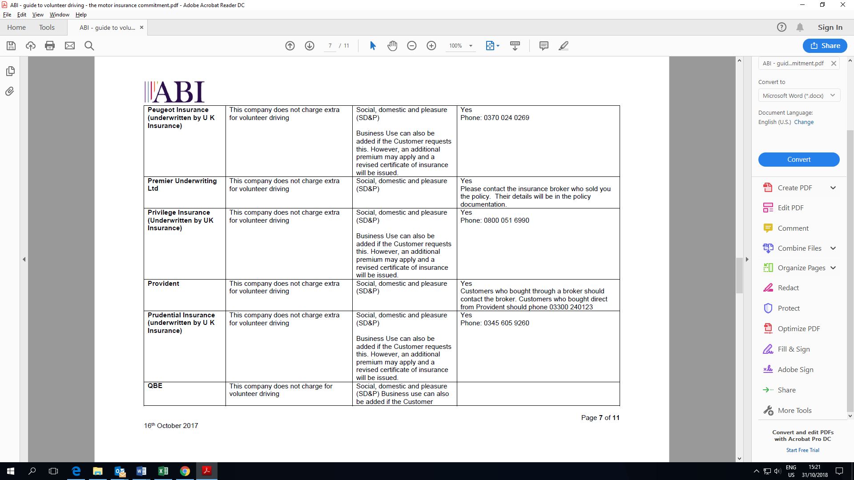

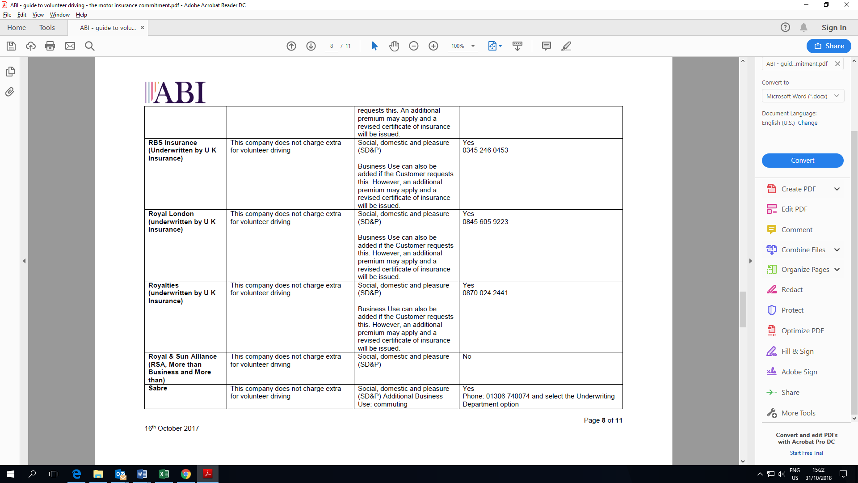

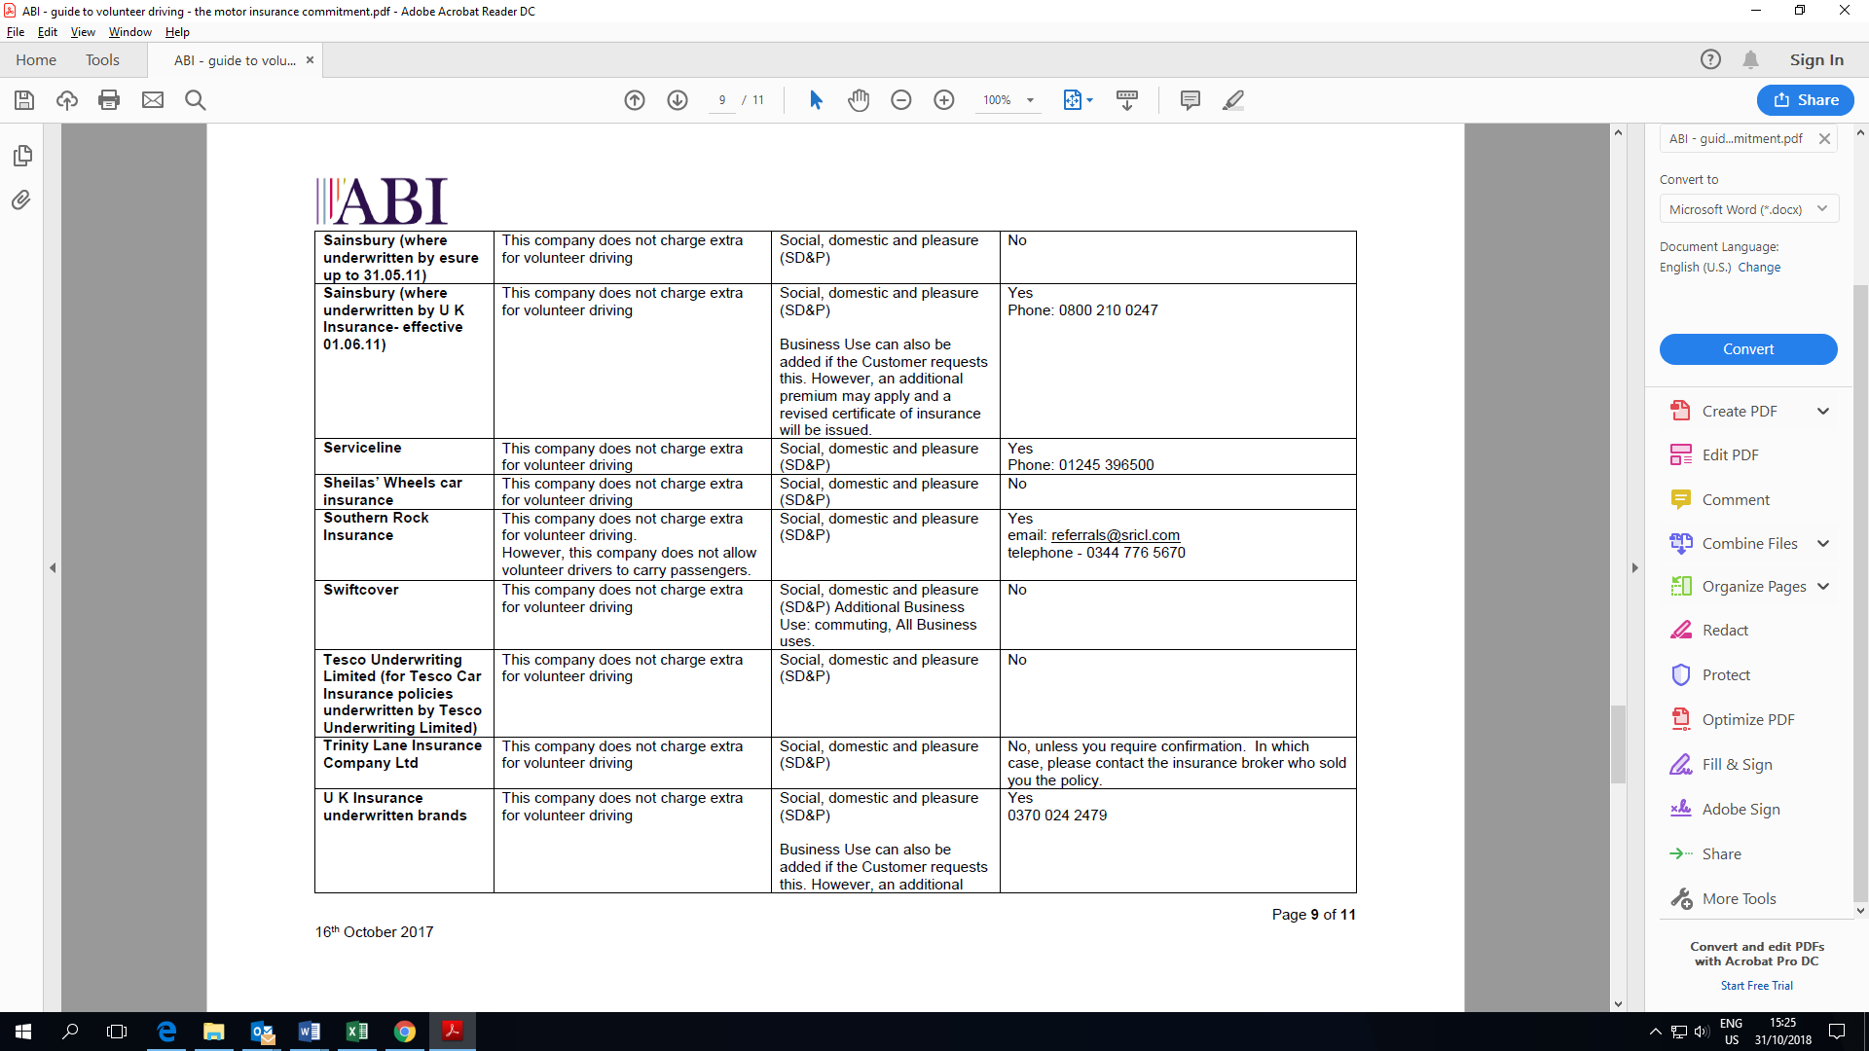

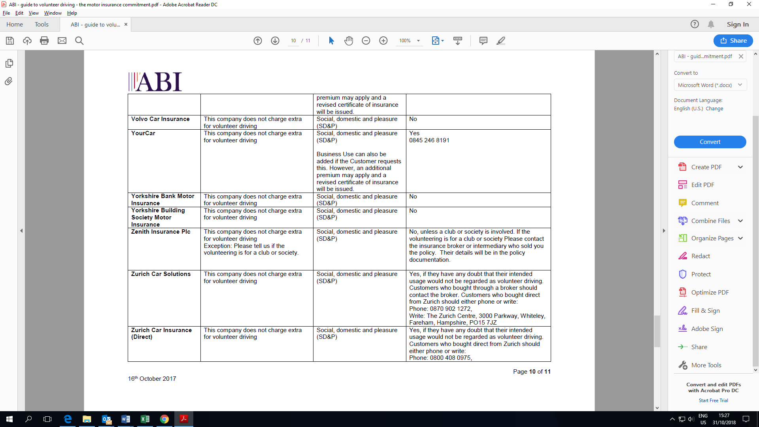

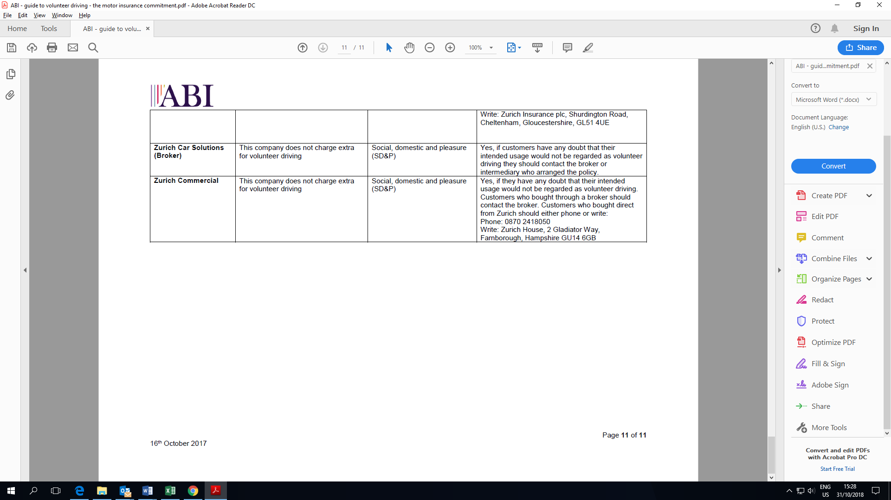

**Appendix seven**

**Log for Registered Standard Driver**

|  |  |  |  |  |
| --- | --- | --- | --- | --- |
| **HUU NO:** | **NAME** | **Student No:** | **DRIVING LICENCE NO:** | **AUTH** |
| HUU/001 |  |  |  |  |
| HUU/002 |  |  |  |  |
| HUU/003 |  |  |  |  |
| HUU/004 |  |  |  |  |
| HUU/005 |  |  |  |  |
| HUU/006 |  |  |  |  |
| HUU/007 |  |  |  |  |
| HUU/008 |  |  |  |  |
| HUU/009 |  |  |  |  |
| HUU/010 |  |  |  |  |

**Log for Private Vehicle Driver**

|  |  |  |  |  |
| --- | --- | --- | --- | --- |
| **NAME** | **Student No** | **Driving License** | **Insurance Docs** | **MOT** |
|  |  |  |  |  |
|  |  |  |  |  |
|  |  |  |  |  |
|  |  |  |  |  |
|  |  |  |  |  |
|  |  |  |  |  |
|  |  |  |  |  |
|  |  |  |  |  |
|  |  |  |  |  |
|  |  |  |  |  |
|  |  |  |  |  |
|  |  |  |  |  |
|  |  |  |  |  |